Swatcha Bharat Abhiyan at Markanday Ghat, Nanded, Maharashtra
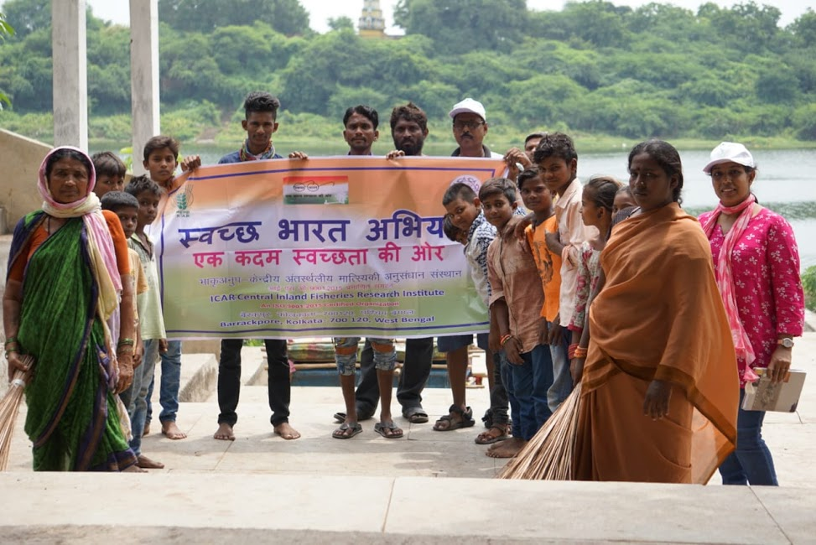
A Swatcha Bharat Abhiyan was organised by the ICAR–CIFRI team members consisting of scientists and technical officers on the banks of river Godavari at Markanday Ghat, Nanded, Maharashtra on 19.09.2018. The local people participated along with CIFRI team members enthusiastically in cleaning the river banks and surrounding areas. The local people appreciated the efforts of CIFRI in keeping the area neat and clean under Swatcha Bharat Abhiyan.
